Bond Enthalpy (Bond Energy)
The Bond Enthalpy is the energy required to break a chemical bond. It is usually expressed in units of kJ mol⁻¹, measured at 298 K. The exact bond enthalpy of a particular chemical bond depends upon the molecular environment in which the bond exists. Therefore, bond enthalpy values given in chemical data books are averaged values.
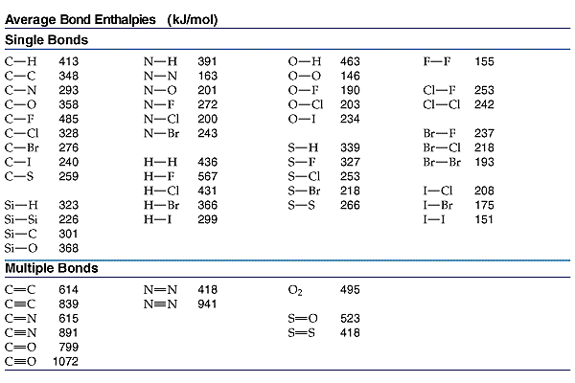
ΔH = ∑ ΔH_{(bonds broken)} - ∑ ΔH_{(bonds formed)}
This basically means that you add up all the energies of the broken bonds; add up all the energies of the bonds that are reformed and subtract one from the other.
EXAMPLE #1
Bond |  | Bond Energy  (kJ/mol)
H-H |  | 436
O=O |  | 499
O-H |  | 463

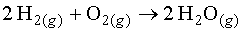
FindH for the following reaction given the following bond energies:

We have to figure out which bonds are broken and which bonds are formed.
2 H-H bonds are broken. 1 O=O bond is broken 2 O-H bonds are formed per water molecule, and there are 2 water molecules formed, therefore 4 O-H bonds are formed
Now we can substitute the values given into the equation: ΔH = ∑ ΔH_{(bonds broken)} - ∑ ΔH_{(bonds formed)}
